**Title: The Thirst for Life: Access to Clean Water in African Communities**

**Introduction**

Water is a fundamental human need, essential for life, health, and dignity. Yet, in many African communities, access to clean and safe drinking water remains a critical challenge. This photographic essay captures the daily struggles, resilience, and hope of people striving to secure this basic necessity.

**Image 1: The Journey Begins**

In the early hours of the morning, before the sun rises, the journey for water begins. Women and children embark on long treks, often spanning several kilometers, to reach the nearest water source. Their determination is a testament to the vital importance of water in their lives.

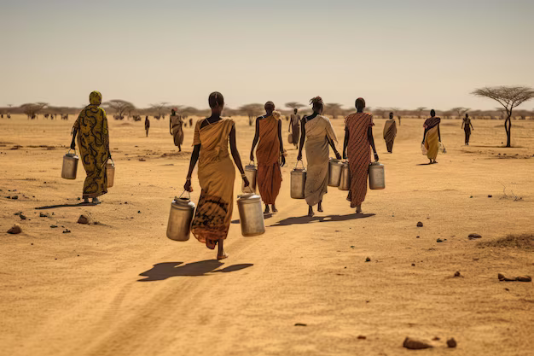Figure 1: A group of women and children walking along a dusty path, each carrying empty jerrycans and containers.

**Image 2: The Source**

The water source is a communal meeting point, where stories are shared, and connections are made. However, the water collected here is often unsafe for consumption, leading to waterborne diseases that plague these communities.

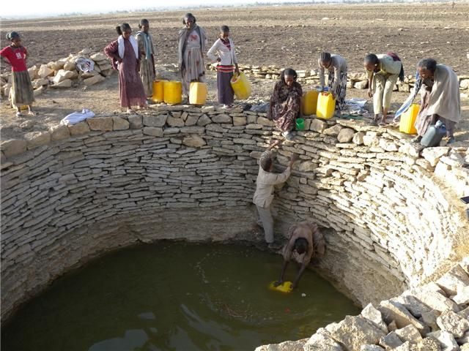Figure 2: A crowded water point with a long line of people waiting their turn to fill their containers from a small, murky pond.

**Image 3: The Struggle**

After fetching water, women and children embark on a long journey under the sun, covering several kilometers, burdened with heavy loads of water as they make their way back home.

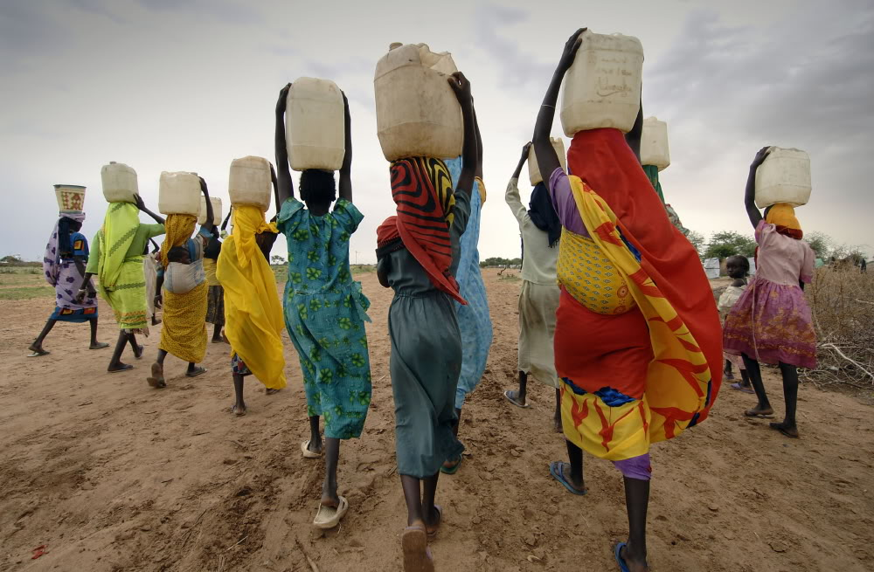Figure 3: A child struggling to carry a heavy container filled with water, the weight causing them to stumble

**Image 4: Innovation and Resilience**

Figure 4: A simple water filtration system created from local materials, providing a glimpse of clean water flowing into a container.

Amidst the challenges, innovation and resilience shine through. Simple, community-led initiatives, such as handmade water filtration systems, offer hope. These small victories are steps toward a healthier and more secure future.

**Image 5: Community Efforts**

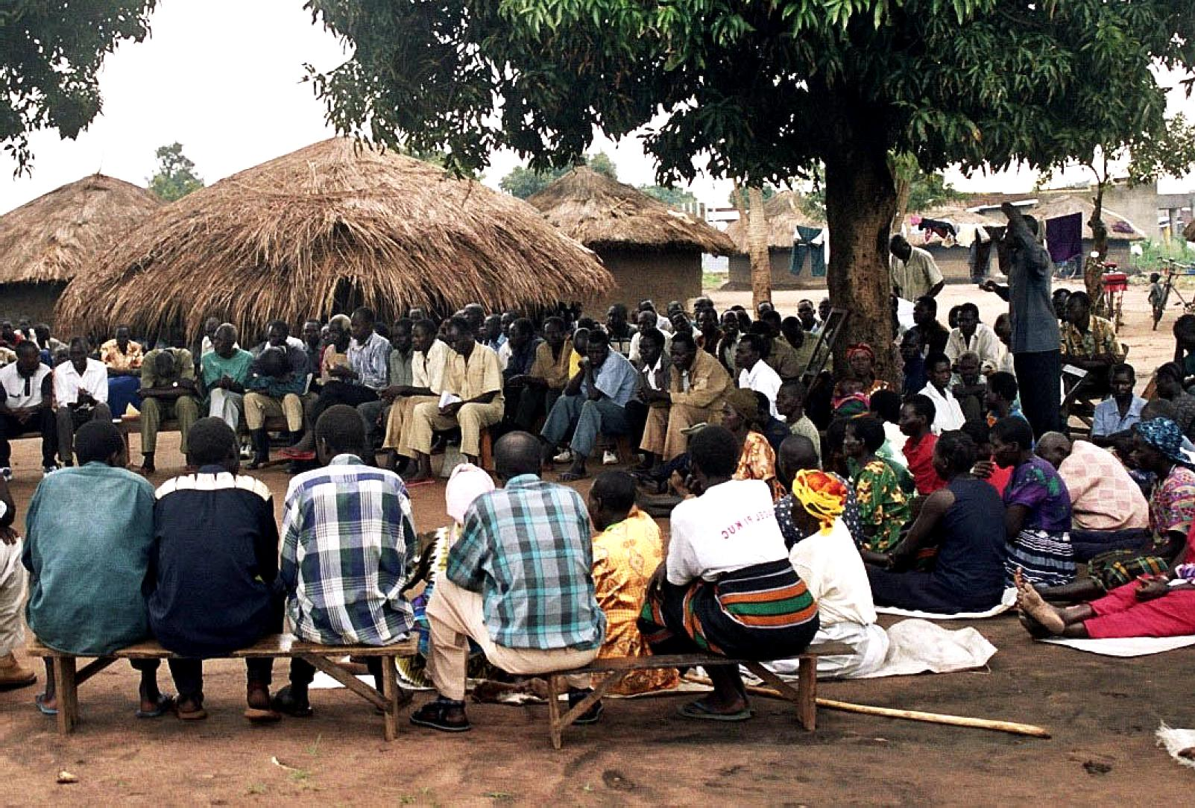Figure 5: A community gathering, working together to install a new well, smiles and laughter filling the air.

The strength of these communities lies in their unity. Together, they work towards sustainable solutions, such as drilling new wells or repairing broken pumps. These collective efforts are crucial in overcoming the water crisis.

**Image 6: The Future**

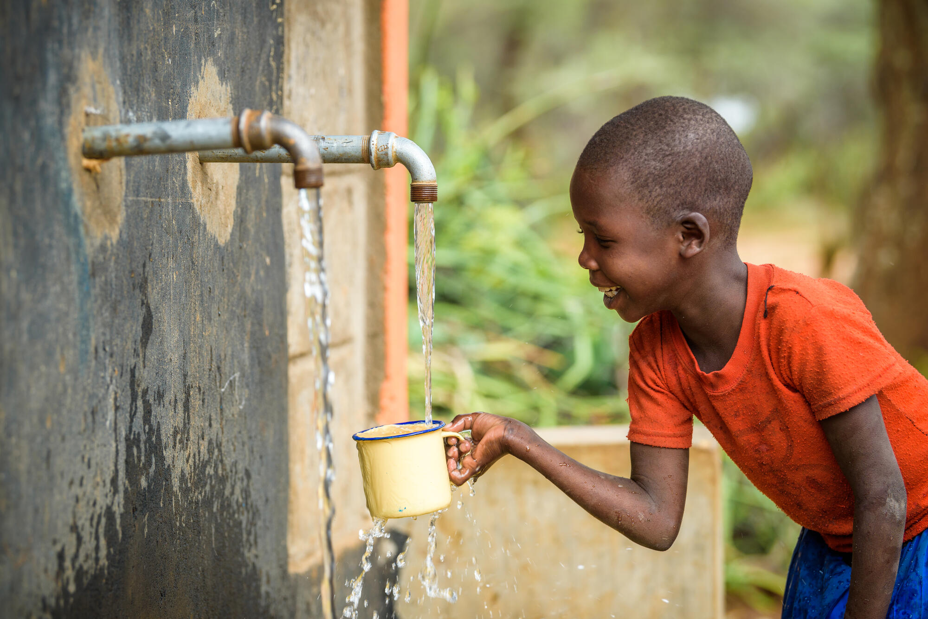Figure 6: A child drinking clean water from a new tap, the joy on their face reflecting the hope for a better future.

Access to clean water transforms lives. It means better health, more opportunities for education, and a brighter future. The joy of drinking clean water is a reminder of what is possible when communities and organizations come together to address this critical issue.

**Conclusion**

Water is life. This photographic essay highlights the ongoing struggle for clean water in African communities and the incredible resilience and determination of those who fight daily for this basic human right. It calls for awareness, action, and support to ensure that every person has access to safe and clean water.